Task Categories and Types
Task categories and types are used to help organize work, so it is easier to report the data that you need. These are completely customizable, and anything could be added or removed at any time based on what types of work you want to track.
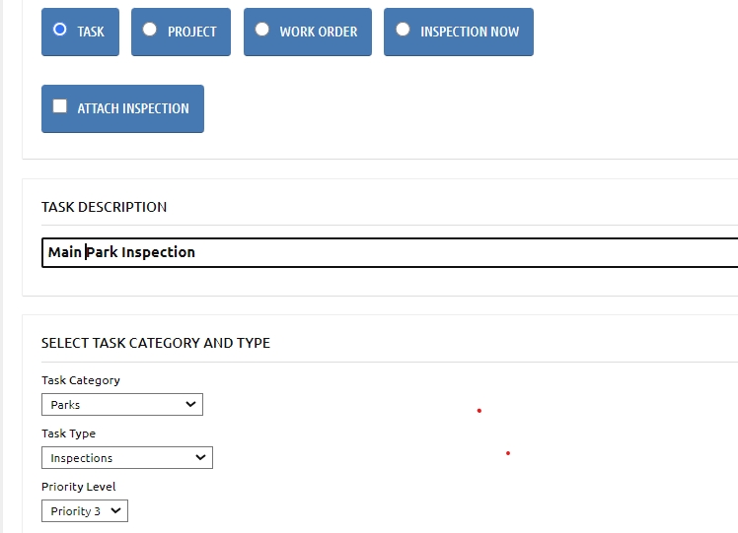
[Task Assignment Screenshot]
Task Categories are the groups that types of activities are listed under when assigning a task, inspection, etc.
Task Types are the types of work performed. They can be repeated under different categories.
In this list, Categories are BOLD and Task Types are normal text.
Please Note: This is a sample of task types and categories. At any point during implementation and beyond, you could revise the task types and categories.
For example, you can build out Turf Maintenance to include things like aeration, topdressing, and dethatching instead of just general maintenance if you wanted to collect data on these individual tasks completed at different assets.
It’s a simple process we will go over during implementation meetings.
Here is a sample/default list of Task Categories and Types:
- Administrative (Task Category)
  - Staff Training (Task Type)
- Athletic Fields
  - Field Preparation
  - General Maintenance
  - Graffiti Removal
  - Inspection
  - Install
  - Preventative Maintenance
  - Remove
  - Repair
  - Replace
  - Setup
  - Take Down
- Building Maintenance
  - Cleaning
  - Custodial
  - General Maintenance
  - Graffiti Removal
  - Inspection
  - Install
  - Preventative Maintenance
  - Remove
  - Repair
  - Replace
  - Set Up
  - Shut Down
  - Start Up
  - Take Down
- Equipment Maintenance
  - Washing
  - General Maintenance
  - Inspection
  - Install
  - Prepare
  - Preventative Maintenance
  - Remove
  - Repair
  - Replace
  - Shut Down
  - Start Up
- Irrigation
  - General Maintenance
  - Inspection
  - Install
  - Preventative Maintenance
  - Repair
  - Replace
  - Shut Down
  - Start Up
  - De-Winterization
  - Winterization
- Landscape Maintenance
  - Aeration
  - General Maintenance
  - Inspection
  - Install
  - Mowing
  - Preventative Maintenance
  - Pesticide Application
  - Remove
  - Repair
  - Replace
  - De-Winterization
  - Winterization
  - Watering
- Litter/Trash Removal
  - Trash Removal
  - Litter Cleanup
- Playgrounds
  - General Maintenance
  - Graffiti Removal
  - Inspection
  - Install
  - Preventive Maintenance
  - Repair
  - Replace
- Snow Duty
  - Snow Plowing
  - Snow Removal
  - Pretreating Surfaces
- Special Events
  - Cleaning
  - General Maintenance
  - Set Up
  - Take Down
- Trails
  - Graffiti Removal
  - General Maintenance
  - Inspection
  - Pavement Maintenance
  - Prescribed Burns
- Tree Maintenance
  - General Maintenance
  - Preventive Maintenance
  - Tree Planting
  - Tree Removal
  - Tree Transplant
- Turf Maintenance
  - Inspections
  - General Maintenance
  - Mowing
  - Mulching
  - Remove
  - Repair
  - Replace
  - Watering
  - Seasonal Work
- Vehicle Maintenance
  - General Maintenance
  - Inspection
  - Preventative Maintenance
  - Repair
  - Replace
  - Seasonal Work
  - Washing

