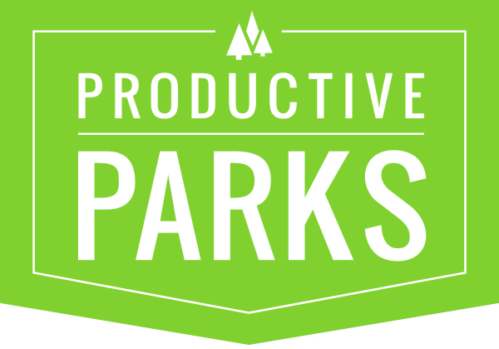
TASK CATEGORIES AND TASK TYPES
Define Task Types and Category Types here – What you do.

Task Categories / Task Types
- Building Maintenance (task category)
  - Window Washing (task type)
  - General Maintenance (task type)
  - HVAC Maintenance (task type)
  - HVAC Preventative (task type)
  - Alarm Maintenance (task type)
  - Annual Service (task type)
  - Appliance Installation (task type)
  - Appliance Repair (task type)
  - Repair (task type)
  - Replace (task type)
  - Electrical Installation (task type)
  - Electrical Maintenance (task type)
  - Elevator Maintenance (task type)
  - Inspection (task type)
- Equipment Maintenance
  - Inspection
  - Oil Change
  - Maintenance
  - Repair
  - Replace
- Event Setup
  - Special Event Clean-up
  - Special Event Take Down
  - Special Event Maintenance
  - Special Event Setup
  - Tent Set-up
  - Tent Take Down
- Irrigation
  - Irrigation Maintenance
  - Irrigation Shut Down
  - Irrigation Controller Repair
  - Irrigation Installation
  - Irrigation Maintenance
  - Inspection
  - Irrigation Repair
  - Irrigation Start Up
- Athletic Fields
  - Base Installation
  - Bench Installation
  - Bench Maintenance
  - Bench Removal
  - Field Layout
  - Field Preparation
  - Field Renovation
- Landscape Maintenance
  - Mowing
  - Mulching
  - Overseeding
  - Watering
  - Aeration
  - Edging
  - Repair
  - Replace
  - Removal
  - Maintenance
  - Inspections
  - Sign Maintenance
  - Bed Edging
  - Bed Preparation
- Playground Maintenance
  - Play Area Audit
  - Playground Installation
  - Playground Maintenance
  - Playground Safety Surface Maint.
  - Playground Swing Maintenance
- Snow Duty
  - Snow Plowing
  - Snow Removal
- Trail Maintenance
  - Path/Trail Maintenance
  - Pavement Maintenance
  - Prescribed Burning
  - Pest Control
  - Pesticide Application
- Trash/Cleanup
  - Litter Removal
  - Empty Trash
- Tree Maintenance
  - Tree Planting
  - Tree Removal
  - Tree Transplant
- Turf Maintenance
  - Mowing
  - Mulching
  - Overseeding
  - Watering
  - Aeration
  - Edging
  - Repair
  - Replace
  - Removal
  - Maintenance
  - Top Dressing
  - Inspections
- Vehicle Maintenance
  - Inspection
  - Oil Change
  - Maintenance
  - Repair
  - Replace

