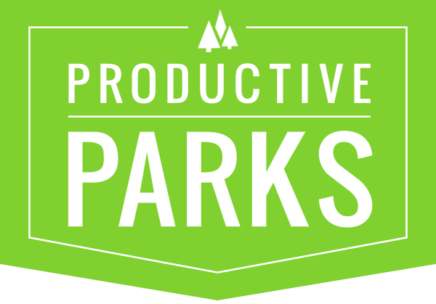
SAMPLE ASSETS AND ASSET CATEGORIES

Please Indicate Manager(s) for Each Asset (also include their email and optional phone number)

Parks (Master Category)
East Parks (category)
Bedrock Park (Master Asset) [Asset Manager ie tom@productiveparks.com]
- Playground (parent asset)
  - Swing Set (sub asset)
  - Slide (sub asset)
  - Fencing (sub asset)
- South Swing Set (asset)
- Climbing Wall (asset)
Cobblestone Park (Master Asset)
Rock Vegas Park (Master Asset)
West Parks (category)
Sandstone Park (Master Asset)
Stone Age Park (Master Asset)
Facilities (Master Category)
Fitness Center (Master Asset)
Community Center (Master Asset)
Rock Quarry Pool (Master Asset)
Hudson Senior Center (Master Asset)

Vehicles (Master Category)
Trucks (category)
Ford F150 T-345 (Master Asset)
Ford F150 T-323 (Master Asset)
Staff Vehicles (category)
Chevy Econoline Van V-446 (Master Asset)
Ford Focus Staff Car C-23 (Master Asset)
Chevy Cruze Staff Car C-26 (Master Asset)
Equipment (Master Category)
Parks Equipment (category)
Back Hoe B-2 (Master Asset)
Back Hoe B-3 (Master Asset)
Mower M-33 (Master Asset)
Mower M-42 (Master Asset)
String Trimmer ST-27 (Master Asset)
String Trimmer ST-29 (Master Asset)
HVAC Equipment (category)
HVAC Unit 21 (Master Asset)
HVAC Unit 31 (Master Asset)

